# Exercise 1

## Q1.

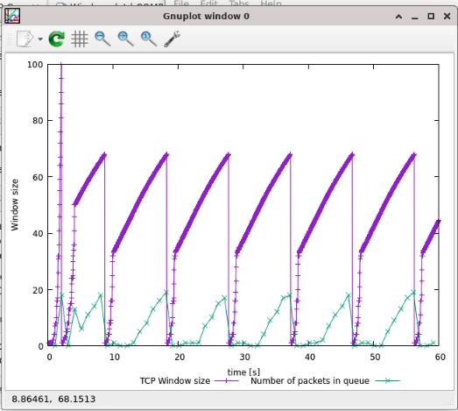

the maximum size of the congestion window that the TCP flow reaches in this case is about 68. At that point, it has timeout event and the congestion avoidance occur and then it slow start restart it. At last, the period repeat.

## Q2.

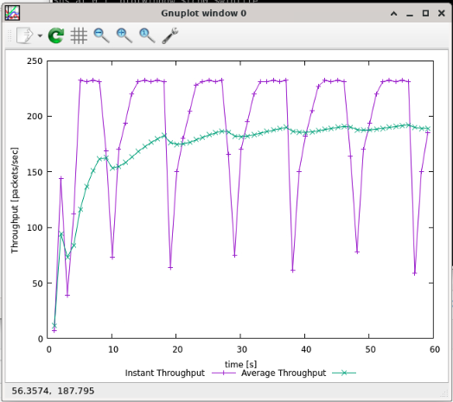

The average Throughput is about 190 packets/sec

So the TCP average Throughput is (500+20+20)*8*190=820.8kbps

## Q3

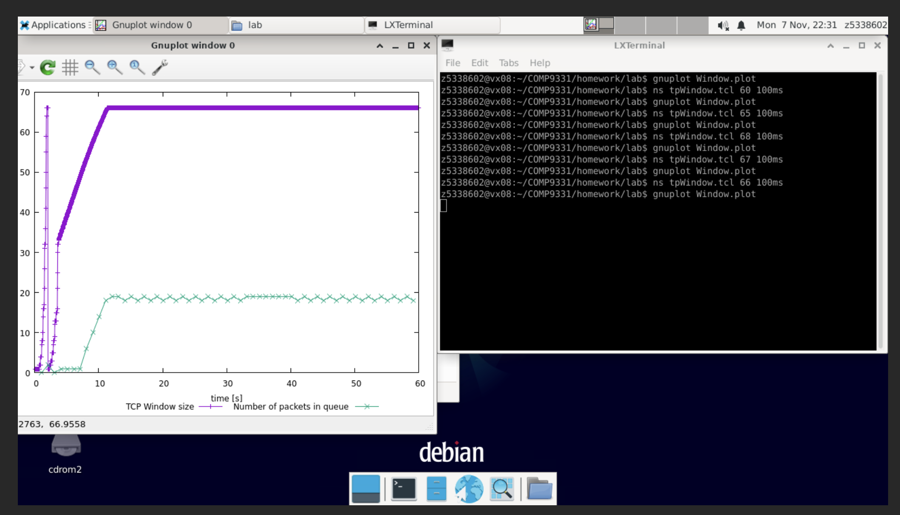

According to the trying, I found maximum congestion window at which TCP stops oscillating is 66.

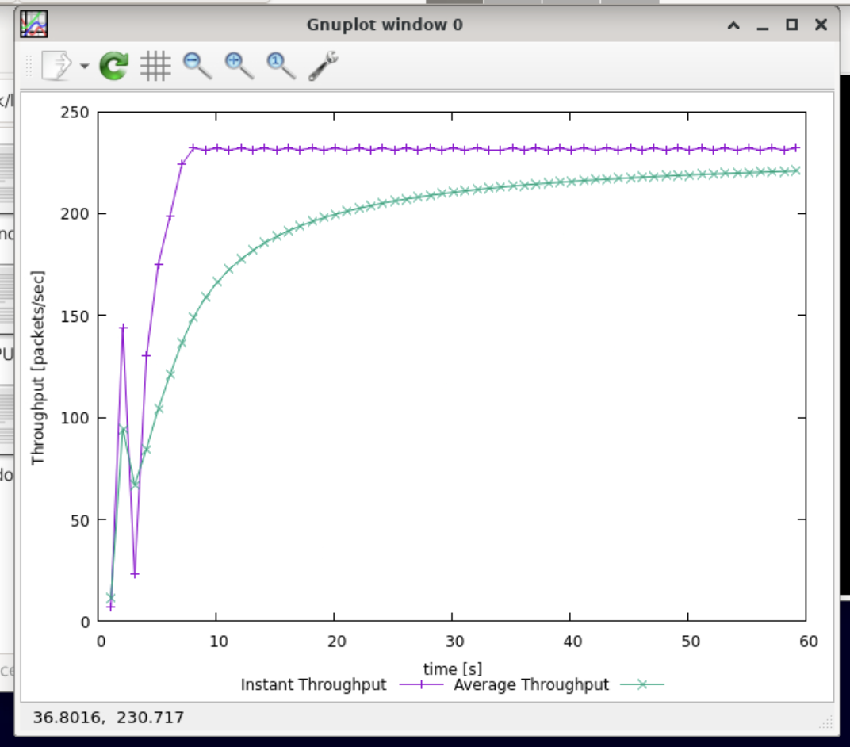

The average Throughput is about 230 packets/sec

So the TCP average Throughput is (500+20+20)*8*230=993.6kbps

And the actual average throughput compare to the link capacity (1Mbps) is similar.

## Q4

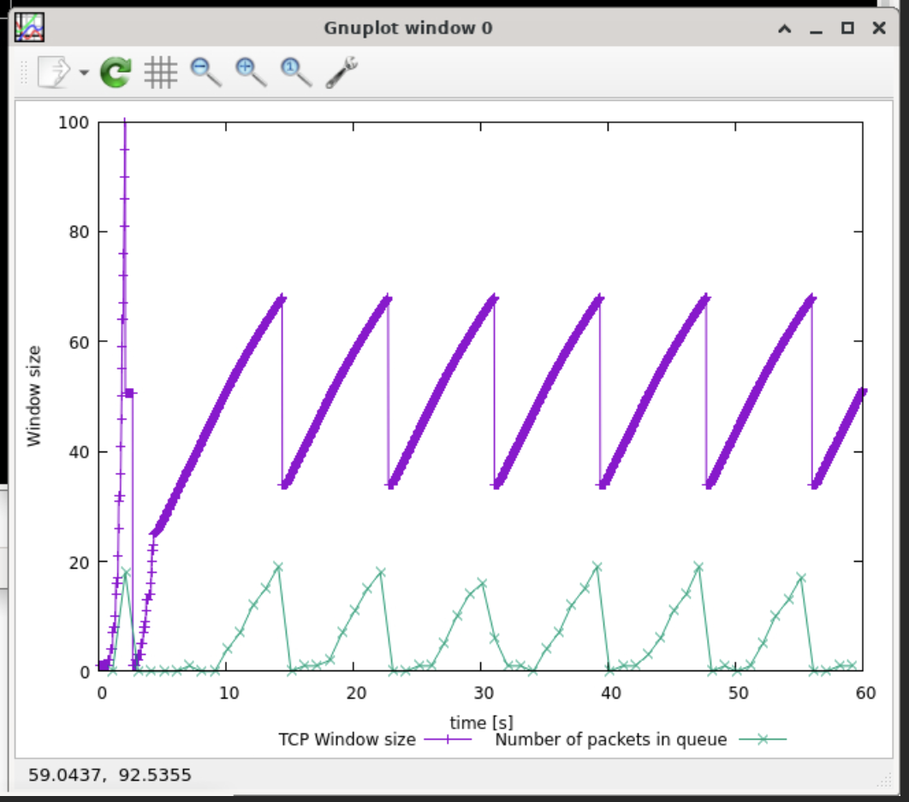

In the Reno plot, the timeout event occur and it only cut down by half when the timeout event occur in the Tahoe it decrease to 1.

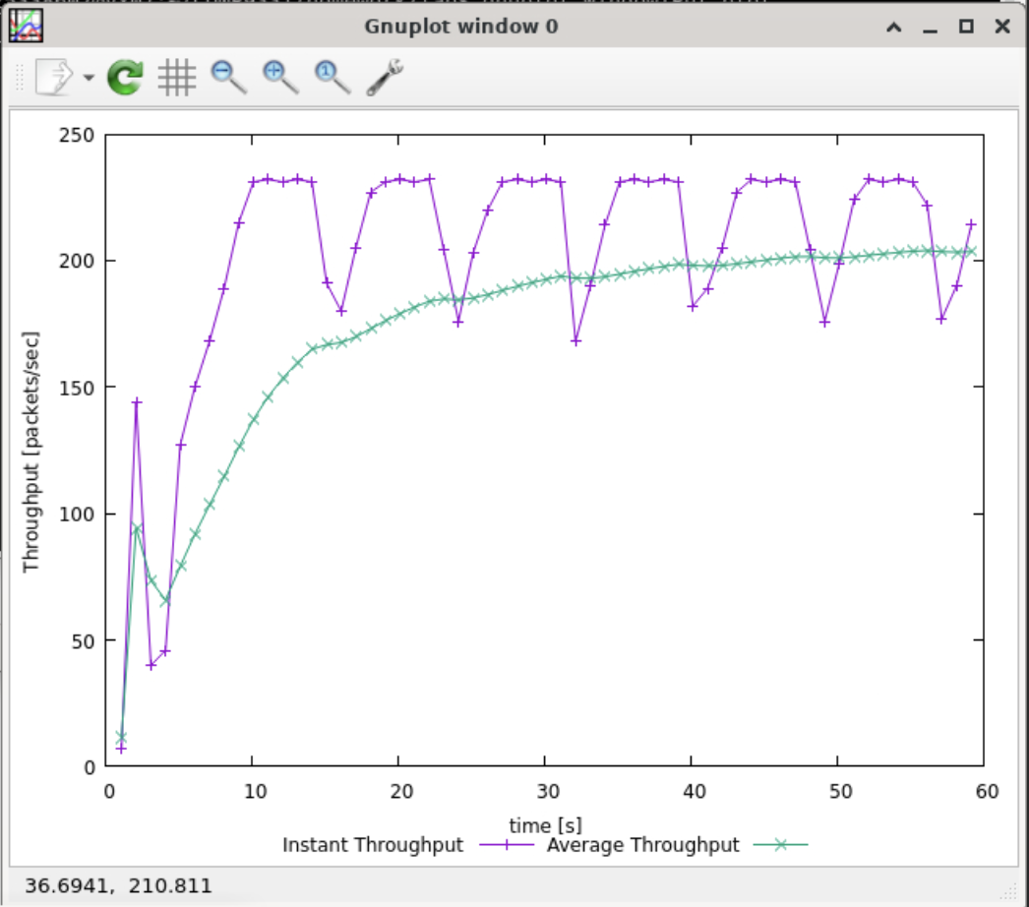

In this time, the average Throughput is about 200packets/sec.

# Exercise 2

## Q1

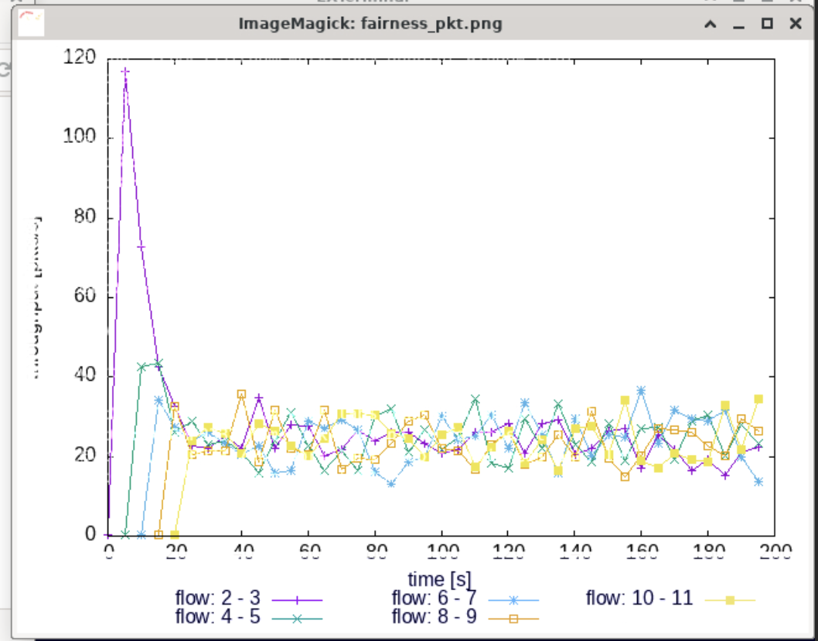

TCP is fair. Each flow gets an equal share of the capacity of the common link. The capacity of each stream will vary at the beginning, but over time, the capacity of all streams will average out to a similar value.

## Q2

The throughput of the pre-existing TCP flows will decrease when a new flow is created. The mechanisms of TCP which contribute to this behaviour is congestion control. It is fair that when the flow is increasing, the throughput of each flow will decrease.

# Exercise 3

## Q1

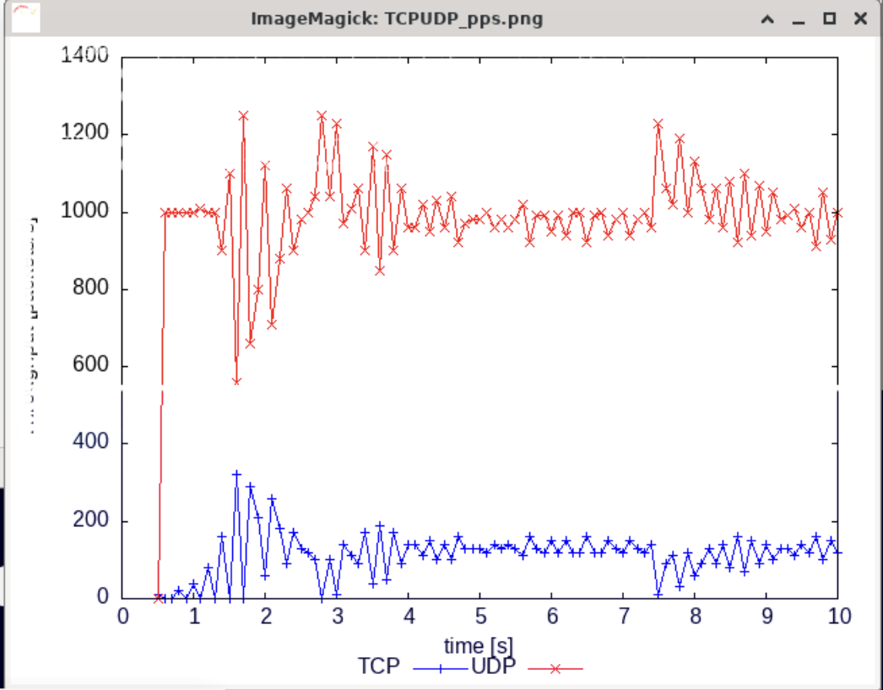

The red line is UDP and the blue line is TCP. I expect the UDP has the higher throughput than TCP.

## Q2

UDP do not has the congestion control so it do not care about the timeout and it has the high throughput while the TCP has the congestion control that it may have the packet loss and so on.

## Q3

The UDP protocol is a connectionless protocol and it has not congestion control, which has high efficiency, fast speed, and occupies less resources. However, UDP is a unreliable protocol, It does not guarantee secure transmission of files, for example when congestion occurs, UDP simply drops packets without any remedial action.